**Air Circuit Breaker**

An **air circuit breaker** is that kind of circuit breaker which operates in air at atmospheric pressure. After development of oil breaker, the medium voltage air circuit breaker is replaced completely by [oil circuit breaker](http://www.electrical4u.com/electrical-switchgear/oil-circuit-breaker.php) in different countries. But in countries like France and Italy, air circuit breakers are still preferable choice up to voltage 15 KV. It is also good choice to avoid the risk of oil fire, in case of [oil circuit breaker](http://www.electrical4u.com/electrical-switchgear/oil-circuit-breaker.php).

There are mainly two **types of air circuit breaker** are available.

1) Plain air circuit breaker

2) Air blast Circuit Breaker.

**Plain Air Circuit Breakers**

Plain air circuit breaker is defined as a circuit breaker, in which the contacts open and close in air at atmospheric pressure. In general, the use of this type of circuit breakers is restricted to low voltage applications or high security installations where the risk of an oil fire or oil contamination of the environment is too high to be tolerated. Countries following the American practice used air circuit breakers almost exclusively for systems up to 15 kV until the advent of the new vacuum and SF6 technologies.

The principles of arc interruption used in an air circuit breaker are rather different from those in any other type of circuit breaker. However, the objective is the same for both categories of the circuit breakers, i.e. to prevent the resumption of arcing after current zero by creating a situation wherein the contact gap will withstand the system recovery voltage; the air circuit breaker does this by creating an arc voltage in excess of the supply voltage.

This can be achieved in three ways:

1- Intense cooling of the arc plasma, so that the voltage gradient is very high  
2- Lengthening the arc path to increase the arc voltage  
3- Splitting up the arc into a number of series arcs

**Air Blast Circuit Breakers**

These circuit breakers employ a high pressure air-blast as an arc quenching medium. The contacts are opened in a flow of air-blast established by the opening of the blast valve. The air-blast cools the arc and sweeps away the arcing products of the atmosphere. Consequently, the arc is extinguished and flow of current is interrupted.

Whenever current at high voltages needs to be interrupted, more breaking units are used, in series. Dry and clean air supply is one of the most essential requirements for the operation of the air-blast circuit breakers.

In addition, other gases such as Nitrogen, Carbon dioxide, and Hydrogen can also be used. But air is preferred because of the fact that the Carbon dioxide tends to freeze, and the hydrogen gas is very expensive.

This type of circuit breaker has been used earlier for open terminal HV applications, for voltages of 245 kV, and 400 kV up to 765 kV, especially where faster breaker operation was required. The interrupting capability of air circuit breaker is usually increased by increasing the normal pressure range. Normally, the pressure level is around 30 to 35 bars. In order to maintain the insulation level and reliability of operation, it is also necessary for the condition of the air to be very dry.

High pressure air at a pressure between 20 to 30 kg/ cm2 stored in the air reservoir. Air is taken from the compressed air system. Three hollow insulator columns are mounted on the reservoir with valves at their basis. The double arc extinguished chambers are mounted on the top of the hollow insulator chambers. The current carrying parts connect the three arc extinction chambers to each other in series and the pole to the neighboring equipment. Since there exists a very high voltage between the conductor and the air reservoir, the entire arc extinction chambers assembly is mounted on insulators

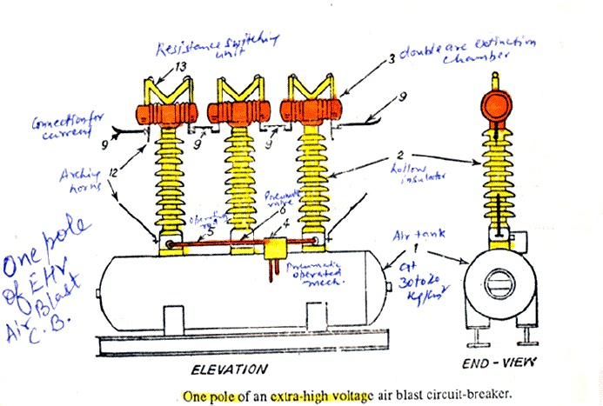

Since there are three double arc extinction poles in series, there are six breaks per pole. Each arc extinction chamber consists of one twin fixed contact. There are two moving contacts. The moving can move axially so as to open or close. Its position open or close depends on air pressure and spring pressure. The operating mechanism operates the rod when it gets a pneumatic or electrical signal. The valves open so as to send the high pressure air in the hollow of the insulator. The high pressure air rapidly enters the double arc extinction chamber. As the air enters into the arc extinction the pressure on the moving contacts becomes more than spring pressure and contacts open. The contacts travel through a short distance against the spring pressure. At the end of the contact travel the port for outgoing air is closed by the moving and the entire arc extinction

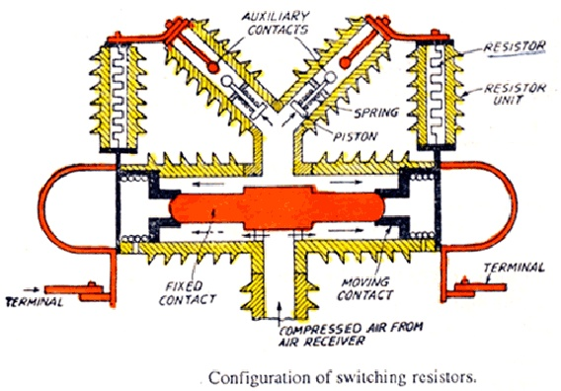

Chamber is filled with high pressure air as the air is not allowed to go out. However, during the arcing period the air goes out through the openings and takes away the ionized air of the arc. While closing, the valve is turned so as to close connection between the hollow of the insulator the reservoir. The valve lets the air from the hollow insulator to the atmosphere. As a result of the pressure of air in the arc extinction chamber is dropped down to the atmospheric pressure and the moving contacts close over the fixed contacts by virtue of the spring pressure. The opening is fast because the air takes a negligible time to travel from the reservoir to the moving contact. The arc is extinguished within a cycle. Therefore, air blast circuit breaker is very fast in breaking the current. Closing is also fast because the pressure in the arc extinction chamber drops immediately as the valve operates and the contacts close by virtue of the spring pressure.

**Advantages:**

1. The risk of fire is eliminated in these circuit breakers.  
2. The arcing products are completely removed by the blast whereas the oil deteriorates with successive operations. So the expenditure of oil replacement is avoided in air-blast cb.  
3. The size of these breakers is reduced, as the dielectric strength grows so rapidly that final contact gap for the arc extinction is very small.  
4. Due to the rapid growth of the dielectric strength, the arcing time is also very small. It causes less burning of oil. The arc energy is also very small fraction of that in oil cb.  
5. The arc extinction is facilitate by the high pressure air, and is independent of the fault current to be interrupted.

**Disadvantages:**

1. These circuit breakers are very sensitive to the variations in the rate of rise of restriking voltage.  
2. The air-blast is supplied by the compressor plant that needs considerable maintenance.

3) Due to high speed current interruption there is always a chance of high rate of rise of re-striking voltage and current chopping.  
4) There also a chance of air pressure leakage from air pipes junctions.

**There are three different categories of air blast circuit breaker.**

a) Axial blast air circuit breaker.  
b) Axial blast air circuit breaker with side moving contact.  
c) Cross blast air circuit breaker.

### Axial Blast Air Circuit Breaker

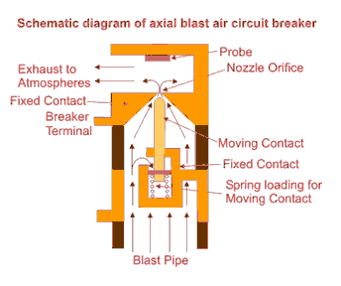

In axial blast air circuit breaker the moving contact is in contact with fixed contact with the help of a spring pressure as shown in the figure. There is a nozzle orifice in the fixed contact which is blocked by tip of the moving contact at normal closed condition of the breaker. When fault occurs, the high pressure air is introduced into the arcing chamber. The air pressure will counter the spring pressure and deforms the spring hence the moving contact is withdrawn from the fixed contact and nozzle hole becomes open. At the same time the high pressure air starts flowing along the arc through the fixed contact nozzle orifice. This axial flow of air along the arc through the nozzle orifice will make the arc lengthen and colder hence arc voltage become much higher than system voltage that means system voltage is insufficient to sustain the arc consequently the arc is quenched.

### Axial Blast Air Circuit breaker with side moving contact

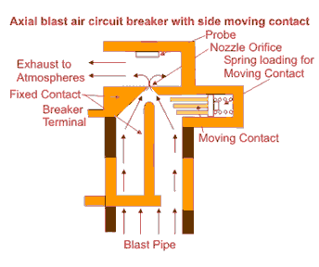

In this type of axial blast circuit breaker the moving contact is fitted over a piston supported over a spring. In order to open the circuit breaker the air is admitted into the arcing chamber when pressure reaches to a predetermined value, it presses down the moving contact; an arc is drawn between the fixed and moving contacts. The air blast immediately transfers the arc to the arcing electrode and is consequently quenched by the axial flow of air.

### Cross Blast Air Circuit Breaker

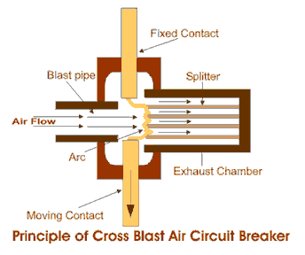

The working principle of cross blast air circuit breaker is quite simple. In this system of air blast circuit breaker the blast pipe is fixed in perpendicular to the movement of moving contact in the arcing chamber and on the opposite side of the arcing chamber one exhaust chamber is also fitted at the same alignment of blast pipe, so that the air comes from blast pipe can straightly enter into exhaust chamber through the contact gap of the breaker. The exhaust chamber is spit with arc splitters. When moving contact is withdrawn from fixed contact, an arc is established in between the contact, and at the same time high pressure air coming from blast pipe will pass through the contact gap and will forcefully take the arc into exhaust chamber where the arc is split with the help of arc splitters and ultimately arc is quenched.